CLOUD COMPUTING



SUBMITTED TO
SIR WAQAS SALEEM

SUBMITTED BY
HAMNA MAHMOOD
2023-BSE-025
BSE V-A

Lab 08
AWS: Account Setup, IAM, VPC Inventory, EC2, Docker & Gitea
Task 1 — Create an AWS account and enable UAE (me-central-1)
task1_open_signup_page
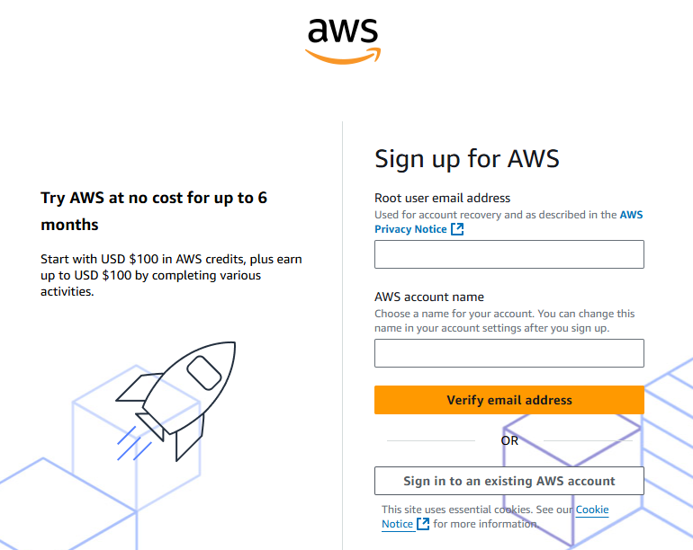
task1_signed_up_confirmation
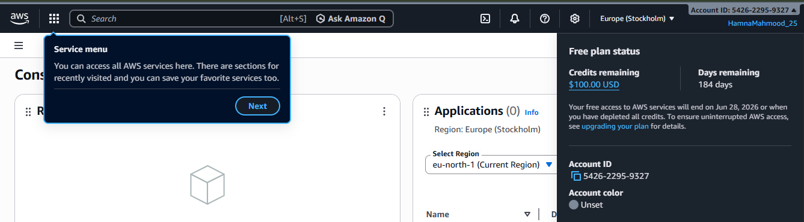

task1_root_signed_in
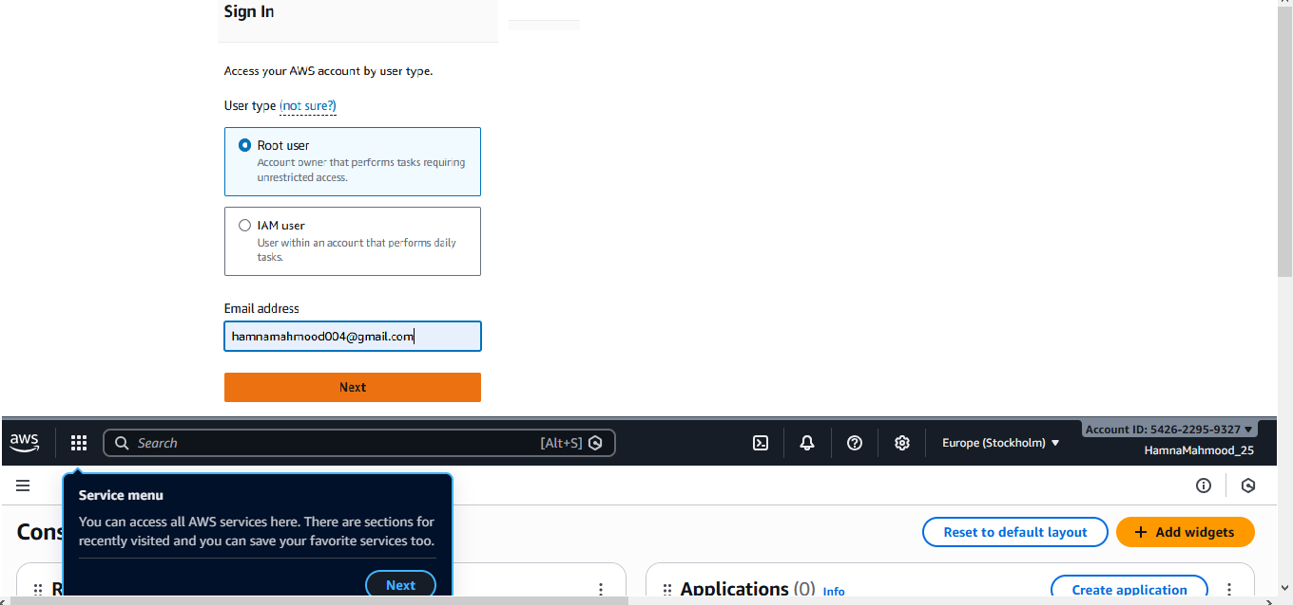
task1_enable_region_me-central-1
task1_summary

Task 2 — Create IAM Admin and Lab8User with console access
task2_open_IAM_console
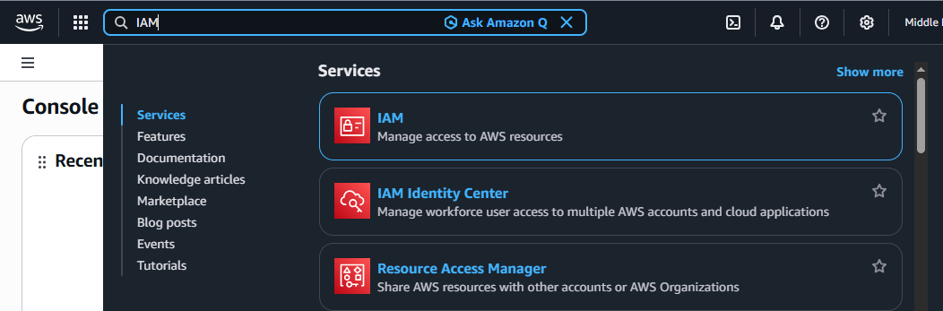

task2_admin_create_confirmation
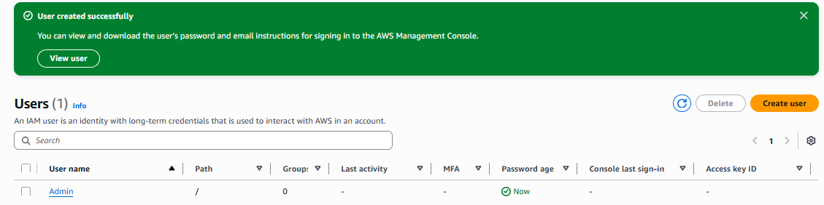
task2_admin_csv_and_signin_url
task2_admin_console_after_login
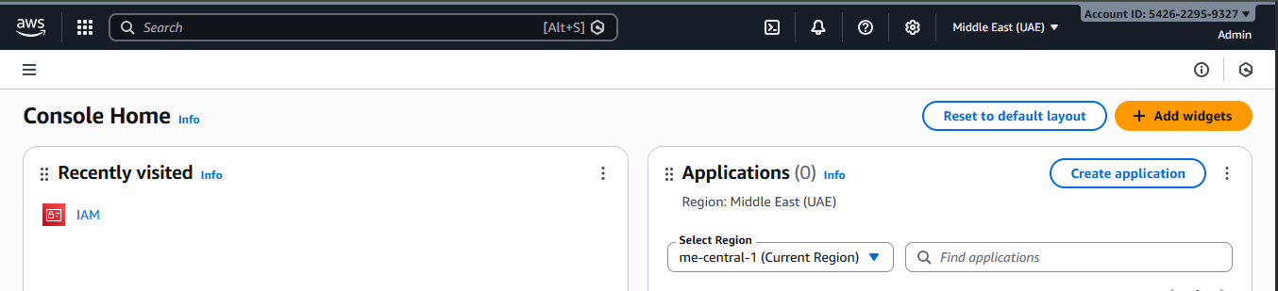
task2_create_lab8user_and_csv
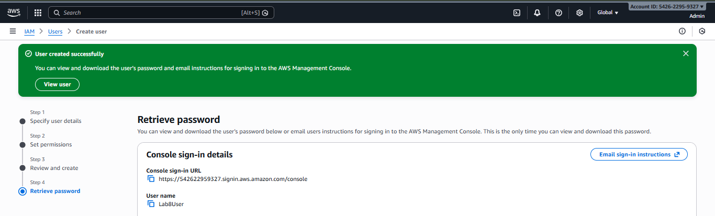
task2_lab8user_csv_saved
task2_lab8user_logged_in
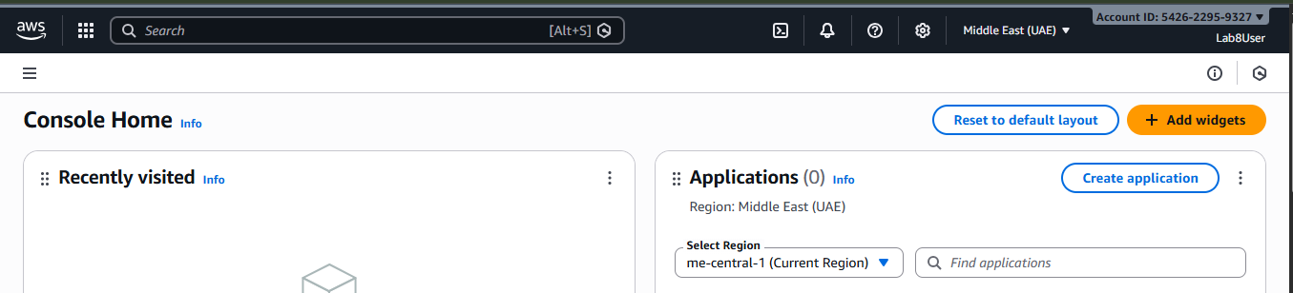
task2_summary
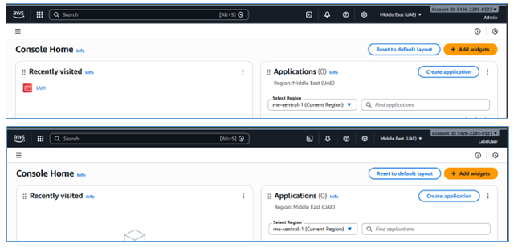

Task 3 — Inspect VPC resources (in UAE me-central-1)
task3_open_vpc_console
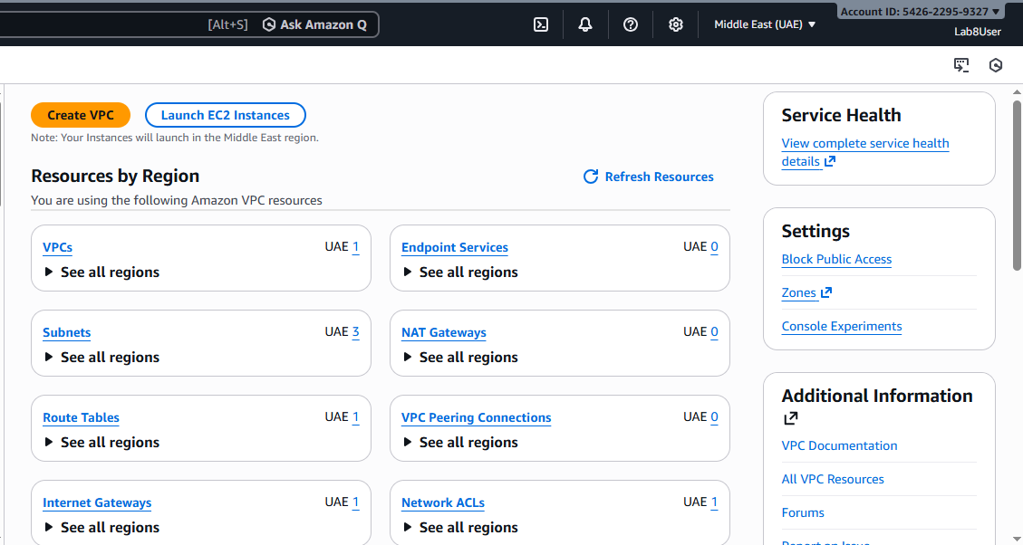
task3_vpc_list
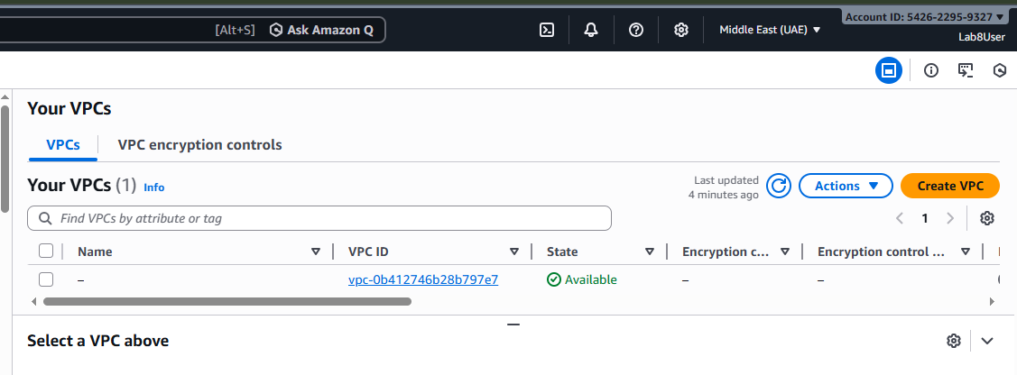
task3_subnet_list
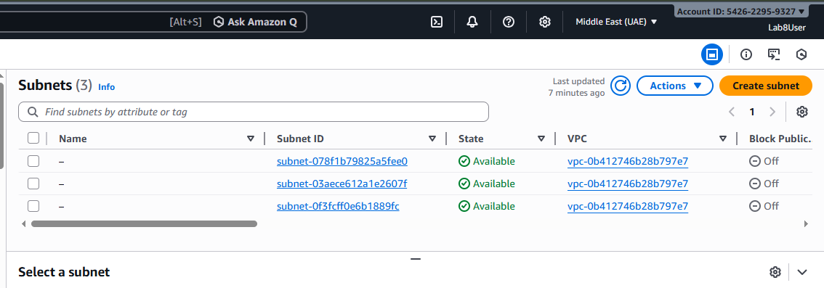
task3_route_tables_list
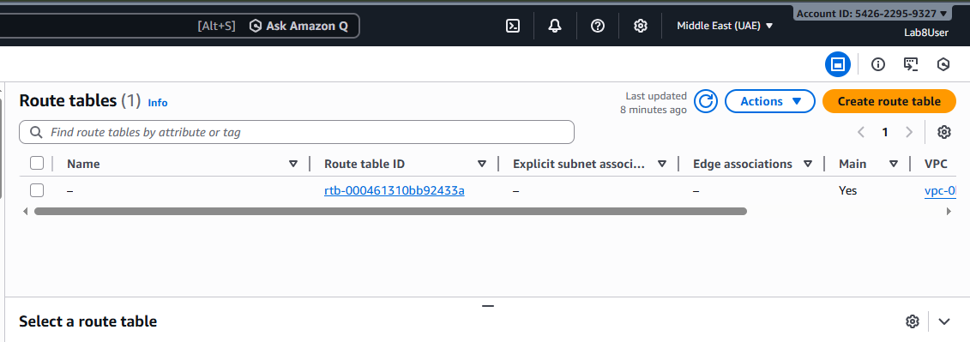
task3_network_acls_list
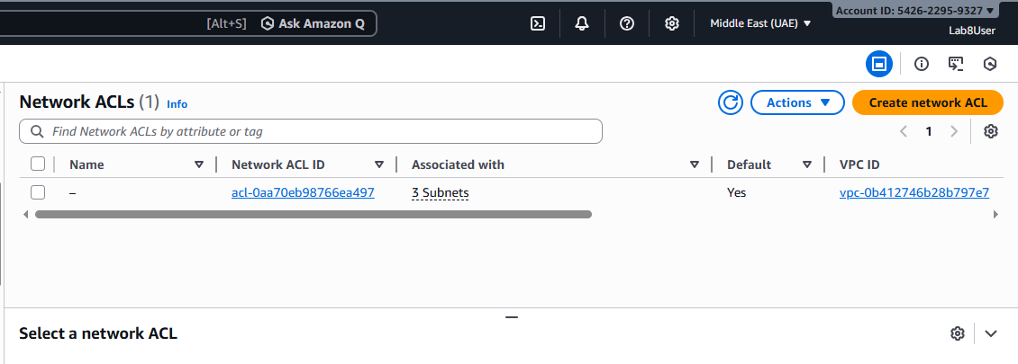
task3_summary
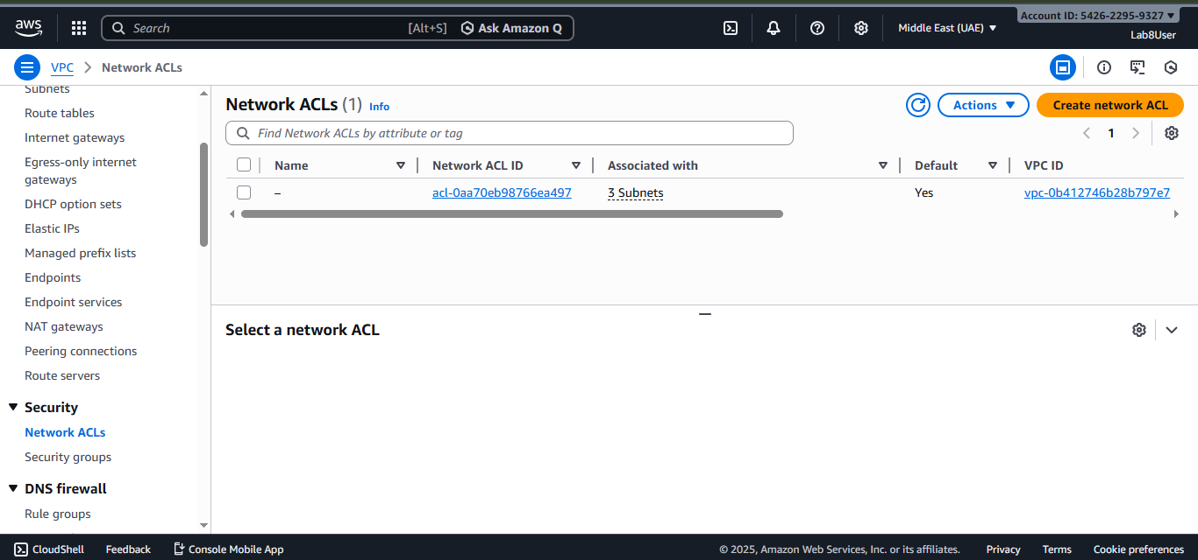
Task 4 — Launch EC2, SSH, install Docker & Docker Compose, deploy Gitea
task4_open_ec2_console
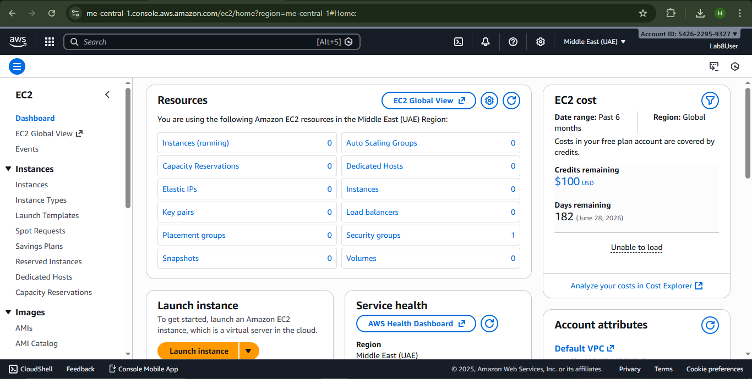
task4_keypair_download
task4_launch_instance_config
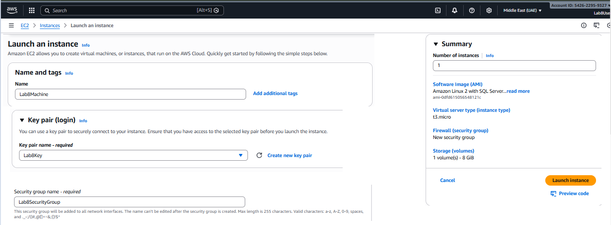
task4_instance_running_console
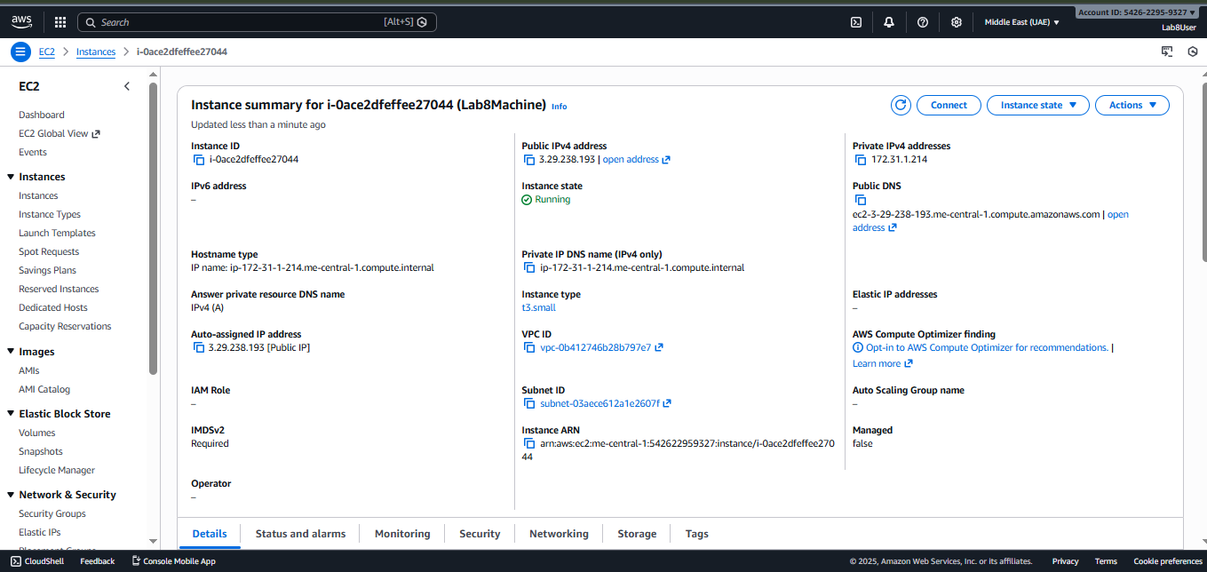
task4_ssh_from_windows_to_ec2
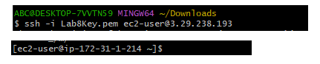
task4_ec2_install_docker_compose_started
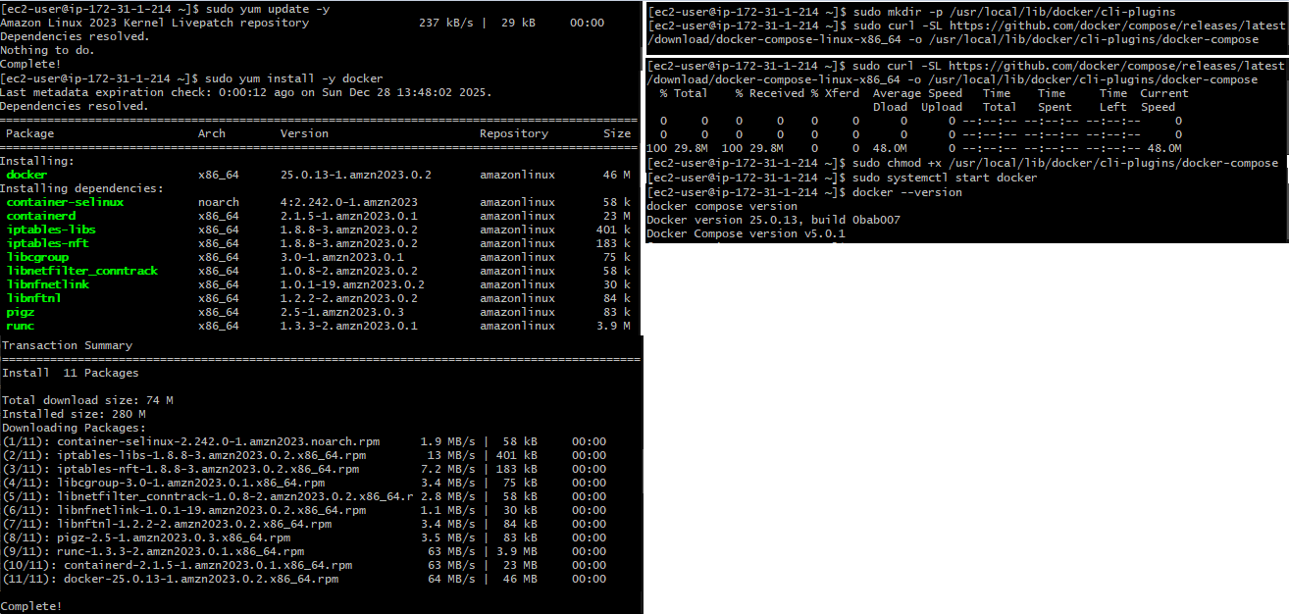
task4_vim_compose_yaml_paste
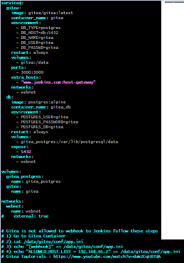
task4_compose_yaml_saved_ls
task4_usermod_and_groups_before_after
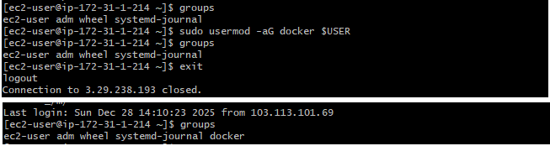
task4_docker_compose_up
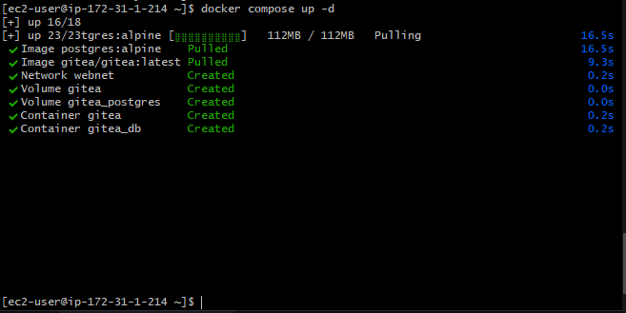
task4_security_group_allow_3000
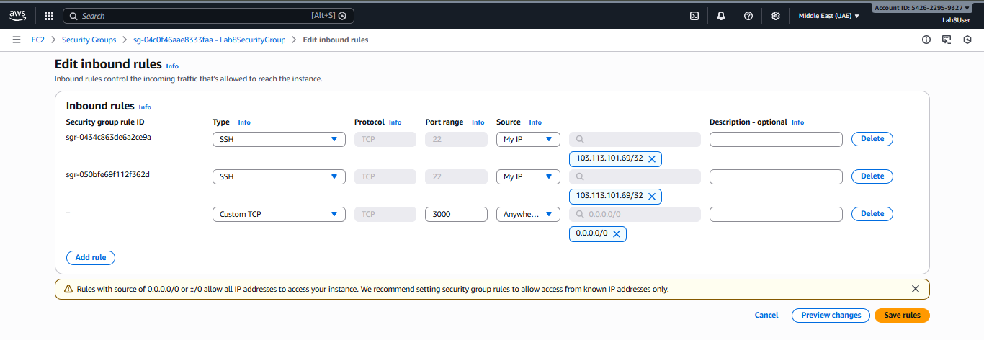
task4_gitea_install_page
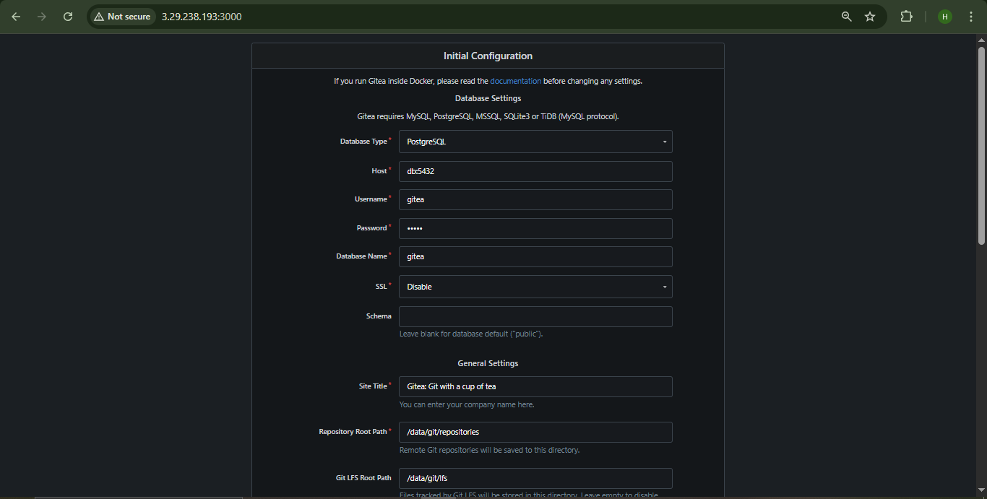
task4_gitea_create_repo
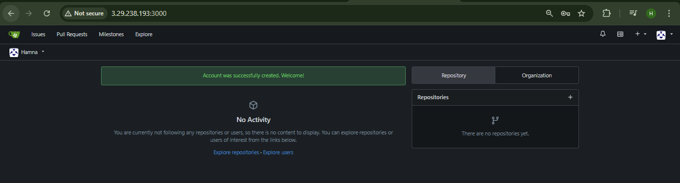
task4_summary
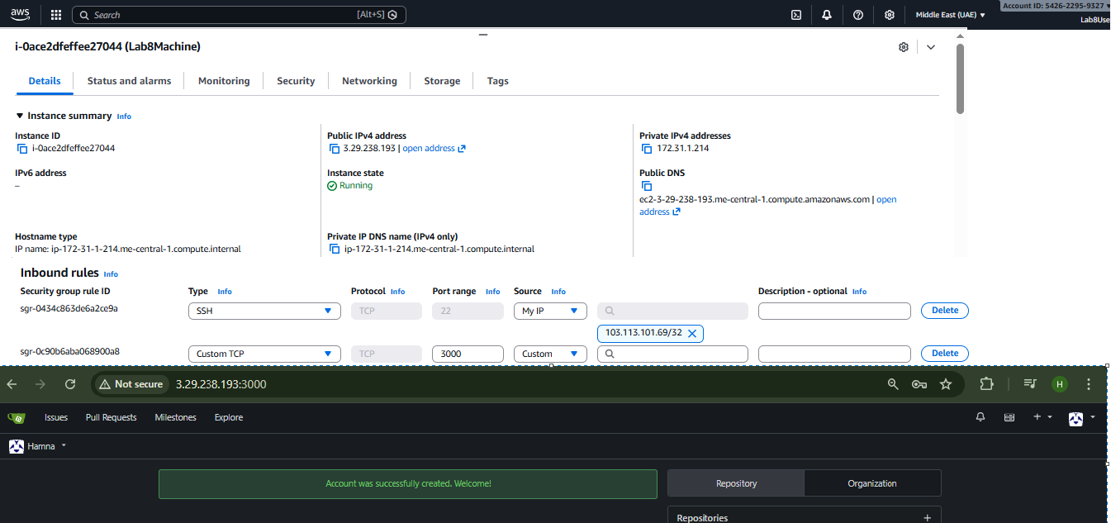
Cleanup — Remove resources to avoid charges
cleanup_terminate_instance
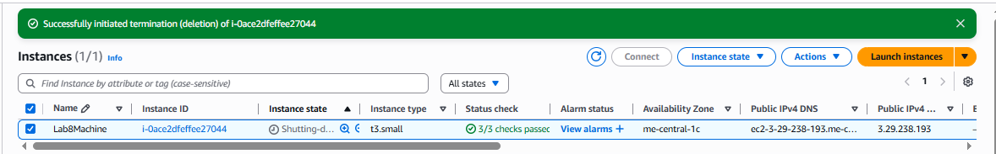
cleanup_delete_volumes_snapshots
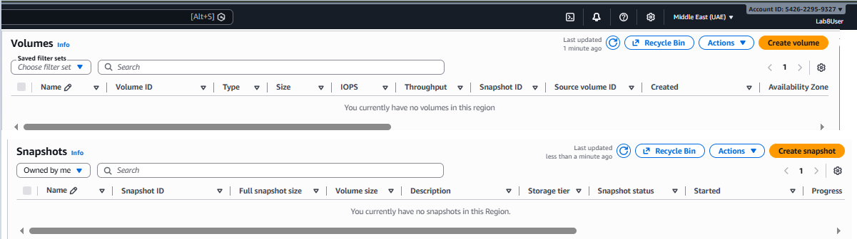
cleanup_delete_security_group_and_keypair
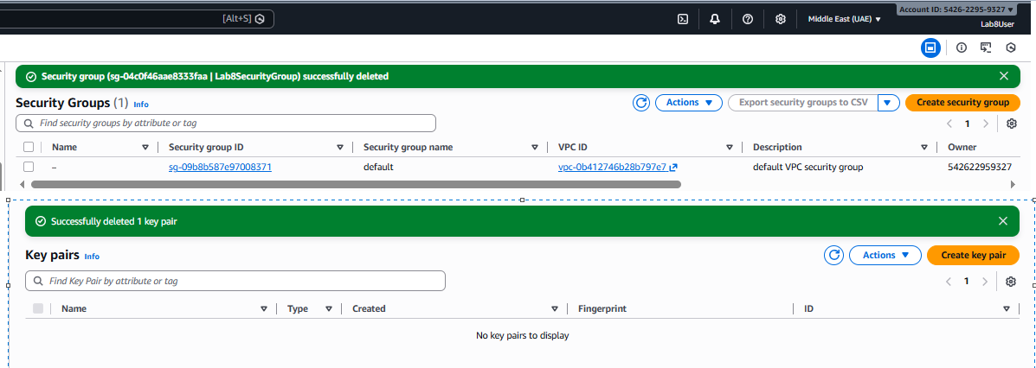
cleanup_iam_users_deleted
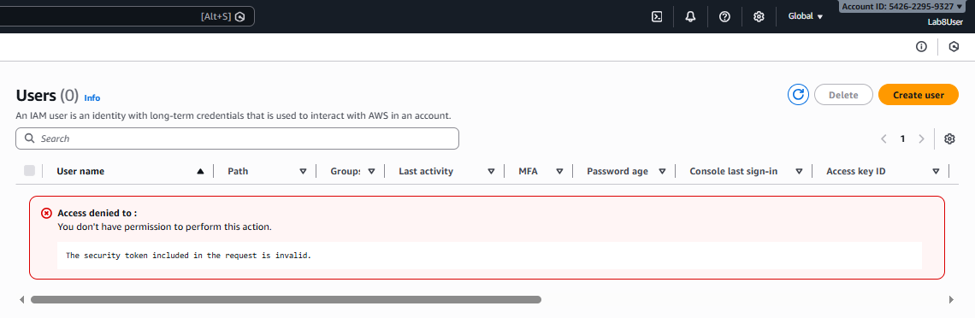
cleanup_summary
